Portable

Heart Monitor

# Amr Gouhar

# Amr Tanawy

# Mohamed Ahmed

# Walaa Mahmoud

# **Introduction**

## A Holter monitor is a small non-invasive ambulatory, portable ECG machine used to record the heart’s electrical activity in a 24–72 hour period. The benefit of ambulatory ECG lies in its ability to examine continuously a patient over an extended period of time, permitting patient ambulatory activity while examining electrocardiographic activity in changing environmental situations.

## 

## Block diagram

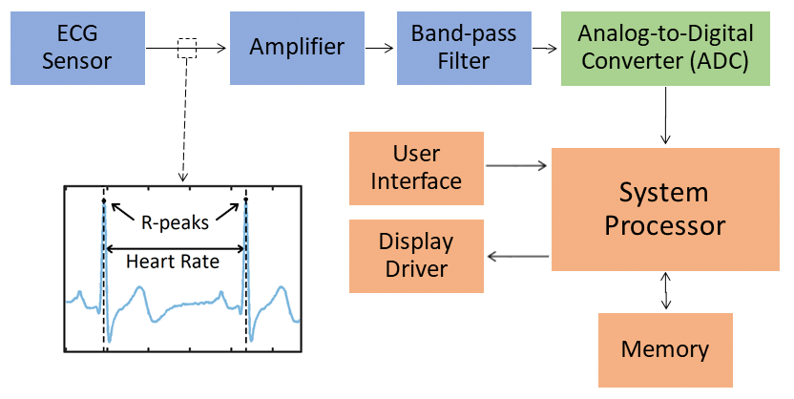

## ECG AND HOW IT WORKS

For the ECG to work we need to check the value of LO- signal and the LO+ signal. If both of them are zero we start converting the ADC signal.To read the ADC signal we need to use HAL_ADC_Start(_)that takes the ADC handle as a parameter. After checking the values of LO- and LO+ and when both of them are zeros we check the value of HAL_ADC_PollForConversion()that takes the adc handle and a time out as parameters, if the value equals to HAL_OK we can get the value of the adc signal using HAL_ADC_GetValue().that also takes the adc handle as a parameter. After that we calculate the needed value by the following equation

[$requirdValue= (adc_value*330)/4096]$

All of this happens in the defaultTask.

## FREE RTOS

We implemented four tasks . the functionality of the first one or the default one is to take the readings from the ECG and than fill the global buffer and store into memory. The second task is for displaying the data from the global buffer when the power is on.the third task is for sending data through bluetooth. And the fourth task is for switching on and off. This task resets the buffer and puts the system on sleep mode.

## EXTERNAL STORAGE

we have a memory pointer to know what is the next memory location to write to. we store the readings in the memory sequentially to make the data analysis more feasible and easier as the memory locations are virtually timestamped. reading Cs low enable CS high then CS low write instruction 3 Byte address then bytes to write. Then Cs high then disable

to read CS low then instruction read then 3 Byte address then we receive bytes until we raise CS to high. we load the memory pointer whenever the system is started or rebooted.

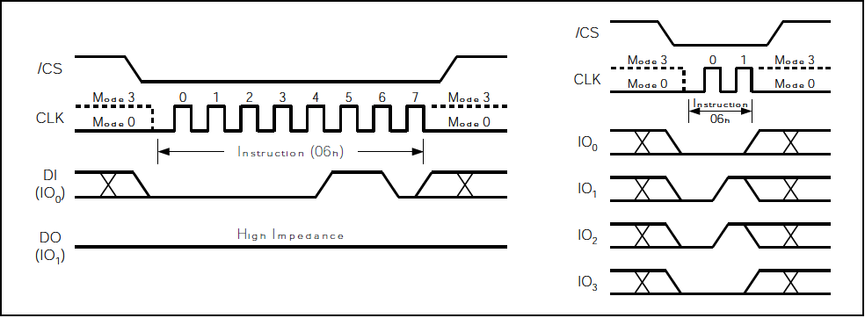

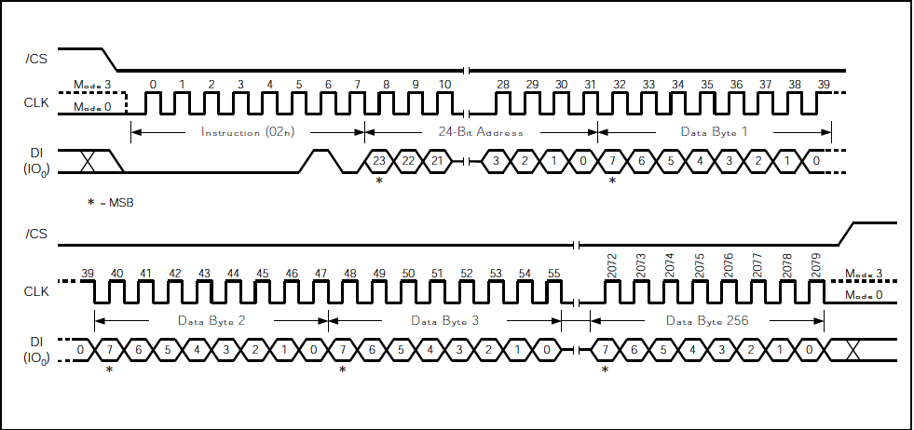

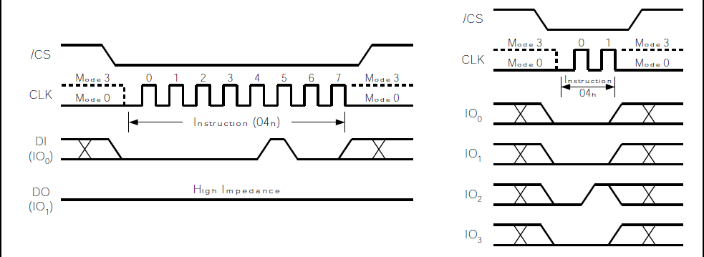

## POWER SOURCE

Lithium Ion Battery 3.7V and 1400 mA. + USB Battery Charger.

## PCB

Main Components:

1. STM32 Microcontroller:
   1. Microcontroller is responsible for handling and controlling all the signals going into ant out of our system. It will receive the reading form the ECG and store it in the Flash memory and end it over Bluetooth to the Mobile application if it is connected. Also it will display the reading on the OLED
2. Bluetooth Module (h-05):
   1. Sending data recorded to the Mobile application for further analysis
3. OLED:
   1. This component displays the heart rate and it is connected to the board of the final product in case Mobile application is not available
4. ECG:
   1. The main component of our system that get the signal of the heart beat and send to the Microcontroller to decide what to do with it
5. Flash Memory:
   1. Storing the readings of ECG to be extracted later for analysis. This memory is non-volatile, after the system is down and back again it will still be restored to be sent over bluetooth for analysis

